1. **Turing Test in Artificial Intelligence:**

The **Turing test** was developed by Alan Turing (Computer scientist) in 1950. He proposed that the **“Turing test is used to determine whether or not a computer(machine) can think intelligently like humans”?**

Imagine a game of three players having two humans and one computer, an interrogator (as a human) is isolated from the other two players. The interrogator’s job is to try and figure out which one is human and which one is a computer by asking questions from both of them. To make things a harder computer is trying to make the interrogator guess wrongly. In other words, **computers would try to be indistinguishable from humans as much as possible.**

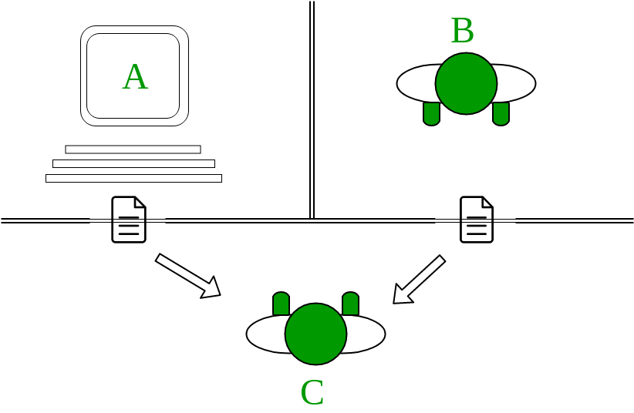

**The “standard interpretation” of the Turing Test, in which player C, the interrogator, is given the task of trying to determine which player – A or B – is a computer and which is a human. The interrogator is limited to using the responses to written questions to make the determination**

**The conversation between interrogator and computer would be like this:   
C(Interrogator):** Are you a computer?   
**A(Computer):** No

**C:** Multiply one large number to another, 158745887 * 56755647   
**A:** After a long pause, an incorrect answer!

**C:** Add 5478012, 4563145   
**A:** (Pause about 20 seconds and then give as answer)10041157

If the interrogator wouldn’t be able to distinguish the answers provided by both humans and computers then the computer passes the test and the machine (computer) is considered as intelligent as a human. In other words**, a computer would be considered intelligent if its conversation couldn’t be easily distinguished from a human’s.** The whole conversation would be limited to a text-only channel such as a computer keyboard and screen.

He also proposed that by the year 2000 a computer “would be able to play the imitation game so well that an average interrogator will not have more than a 70-percent chance of making the right identification (machine or human) after five minutes of questioning.” **No computer has come close to this standard.**

But in the year 1980, Mr John Searle proposed the “**Chinese room argument**“. He argued that the Turing test could not be used to determine “whether or not a machine is considered as intelligent like humans”. He argued that any machine like [ELIZA](https://en.wikipedia.org/wiki/ELIZA) and [PARRY](https://en.wikipedia.org/wiki/PARRY) could easily pass the Turing Test simply by manipulating symbols of which they had no understanding. Without understanding, they could not be described as “thinking” in the same sense people do. We will discuss more this in the next article. 

***In 1990, The Newyork business man Hugh Loebner announce to reward $100,000 prize for the first computer program to pass the test. however, no AI program has so far come close to passing an undiluted Turing Test***

1. **Artificial intelligence can be categories by job capacity and competence in the following two types:**
2. **Weak artificial intelligence:**A type of artificial intelligence with a design for a personal assistant, customer relationship, video games, and questionnaires known as weak artificial intelligence. It consists of a small algorithm and data source. The algorithm and data source related to the data associated with the service industry some of the weak AI examples are – a. Amazon Alexa b. Railways Disha c. Apple’s Siri.
3. **Strong Artificial Intelligence:**It is a system that carries on the task directly performed by humans like vehicle driving. This type of task is more complex and considered under a complicated system. They are program to handle situations in which the decision may be situational changes or unpredicted these kinds of systems developed under strong AI and testing of these systems very difficult but very useful for human beings. This categorization of AI able to replace the manual human operative task by a programmed machine. These machines today most popularly available with an intelligent system such as robots, which treated as the same rights as humans.
4. **Turing Test:**

Alan Turing proposed a simple method of determining whether a machine can demonstrate human intelligence. If a machine engages in a conversation with a human how to process the data it has been demonstrated by a machine, He has proposed the following skills of the test as follows:

The turning judges the conversational skills of humans. According to this test, a computer program can think a proper response for humans. This test matching the conversational data from the existing data through an algorithm and back respond to humans.